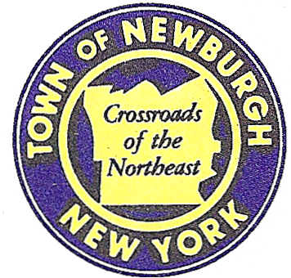

TOWN OF NEWBURGH
_______Crossroads of the Northeast __________________________
OLD TOWN HALL
308 GARDNERTOWN ROAD NEWBURGH, NEW YORK 12550

PLANNING BOARD
JOHN P. EWASUTYN, CHAIRMAN
TELEPHONE 845-564-7804
FAX 845-564-7802
E-MAIL: planningboard@townofnewburgh.org

PLANNING BOARD AGENDA

June 1st, 2017

*PLEASE NOTE: The Planning Board Meeting will start at 7:00 P.M. and all Applicants/Representatives
are to be present at that time. The Meeting will be held in the Meeting Room of Town Hall,
located at 1496 Route 300, Newburgh NY.*

1. The Ridge (f/k/a The Loop) (17-01) PUBLIC HEARING
Rt. 300 & Rt. 52
Section, Block, Lot: Multiple Lots
Zone: IB & R-3
Rep: Divney Tung Schwalbe, LLP
1 North Broadway
White Plains, NY 10601

2. Hurlburt Two Lot Subdivision (17-09) PUBLIC HEARING
Pressler Road
Section 4, Block 2, Lot 41.22
Zone: RR
Rep: Talcott Engineering Design, PLLC
1 Gardnertown Road
Newburgh, NY 12550

3. Fabrizio Two Lot Subdivision (17-05)
Gardnertown Road TWO LOT SUBDIVISION
Section 51, Block 9, Lot 9
Zone: R-1
Rep: Talcott Engineering Design, PLLC
1 Gardnertown Road
Newburgh, NY 12550

4. US Crane & Rigging (16-14) SITE PLAN/SPECIAL USE
18 Route 17K
Section 97, Block1, Lot 21.2
Zone: IB
Rep: Maser Consulting, P.C.
555 Hudson Valley Avenue, Suite 101
Newburgh, NY 12550

5. Terrizzi Subdivision II (17-07) 4 LOT SUBDIVISION
Terrizzi Drive
Section 4, Block 2, Lot 5.4
Zone: RR
Rep: Christopher Terrizzi, PE
170 Long Lane

Newburgh, NY 12550

6. Najork & Roseton Ridge Lot Line Change (17-16) INITIAL APPEARANCE
215 Oak St. & River Rd LOT LINE CHANGE
Section 9, Block 1, Lot 43 & 35
Zone: R-1
Rep: Borbas Surveying and Mapping LLC
402 Main Street
Boonton, NJ 07006

7. OPR Associates (17-17) INITIAL APPEARANCE
NYS Route 300 TWO FAMILY DWELLING
Section 3 Block 1 Lot 140 ARB
Zone AR
Rep: Mercurio, Norton, Tarolli & Marshall
43 Main Street
Pine Bush, NY 12566

8. OPR Associates (17-18) INITIAL APPEARANCE
NYS Route 300 TWO FAMILY DWELLING
Section 3 Block 1 Lot 141 ARB
Zone AR
Rep: Mercurio, Norton, Tarolli & Marshall
43 Main Street
Pine Bush, NY 12566

PLANNING BOARD BUSINESS
WORK SESSION

1) Zazon (04-29)—six month extension – June 15 2017 to December 15 2017.

*WORK SESSION*
Project Readiness Discussion scheduled for 5:30 p.m. in the Meeting Room of
Town Hall on Thursday, June 1st, 2017.*

